MA5951 Assessment 6
Introduction –
The A_Level_Data is a results-based data collection reported by Ofqual for the A-Level exams for the 2019-2020 period which the Excel sheet in question shows the number of students awarded grades between A* - U in multiple different subjects’ categories. This study sets to examine the changes that occur between each grade in the 2019 A-Level exam results for the most popular subjects compared to the 2020 Exam results and see if the changes are contributed to outside influences such as the Covid-19 Pandemic or whether it was just a year of improvement. To achieve this, looking at features such as the subject -Psychology as it can be seen to have its number of Astar2019 effectively double from 2604.882 to 5628.150 with only 514 extra participants in 2020, would give the opinion that there was an impact on the exams. Also, in addition to this, the use of statistical modelling and descriptive analysis will allow for a greater understanding as from the data set alone it can be seen to show an increase in higher grades throughout the different subject categories which is seen to be consistent with numerous sources (Scottish Government, 2020) (Express & Star , 2020). The investigation from this study will allow us to discuss the features of whether firstly there was a noticeable different in the results and secondly, if so, what could have caused the changes and whether it was significance in its impact.
So, for this study a wider context must be considered as A-level results have a drastic impact on student’s futures and therefore seeing drastic changes must be investigated. As when looking at why do A-Level results matter for student’s it could be the path for their futures as well as their next stage of their career (education or job). Therefore, looking into the impact the Coivd-19 pandemic had in 2020 as there was no examinations in June 2020 (Cambridge International, 2020) should also be taken into consideration as with the introduction of lockdown, many students were at home and missed out on many hours of teaching time so with that knowledge it’d give the perception that there might be a fall off on the results compared to last year and not an increase which from the data can be seen to occur.
The use of additional data to support that there were changes in the 2019-2020 A-Level results will be demonstrated by sources via articles, news reports etc. It also includes the use of A-level results in wales as well as England in 2018/19 and 2019/2020 so that when comparing them to the original data set that we’ve for 2019-2020 period, it could show whether there has been a steady increase each year which could be used to either support or challenge that Covid-19 had a significant impact as it could give the perspective that Covid-19 didn’t have as much of an impact as made to believe.

Descriptive Statistics and Graphical Summaries

The Top 6 Subjects from the number of A-level participants in 2019 which due to the larger amounts of participant data, would allow better arguments to be formed.
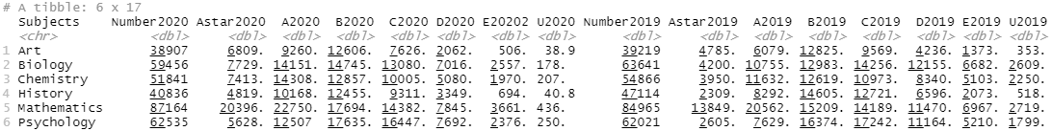
Refined Pie Charts to show visually the change in participants over the Year
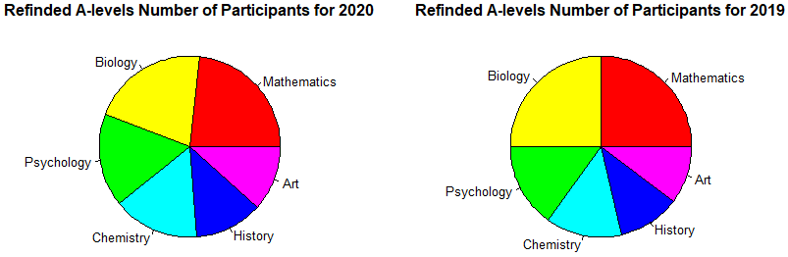
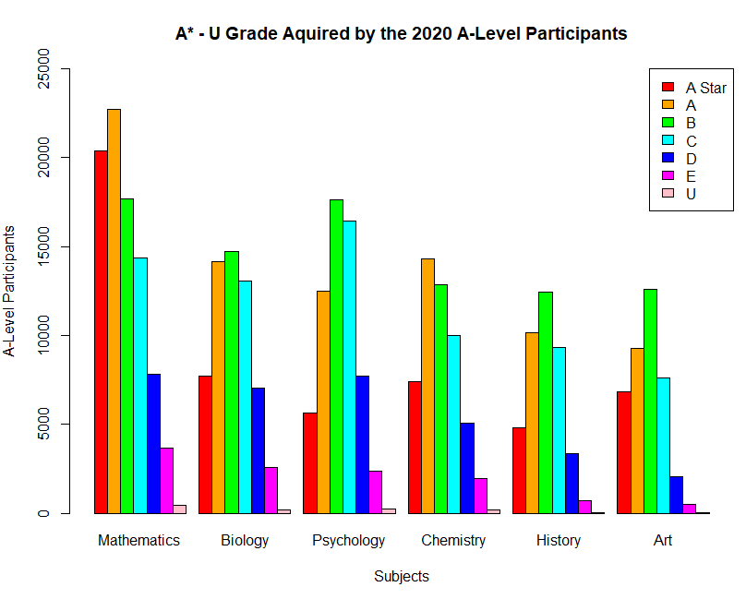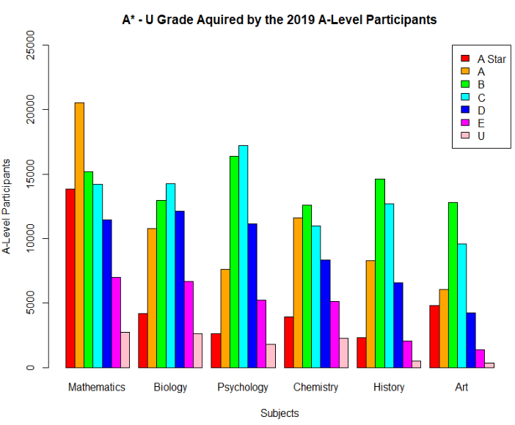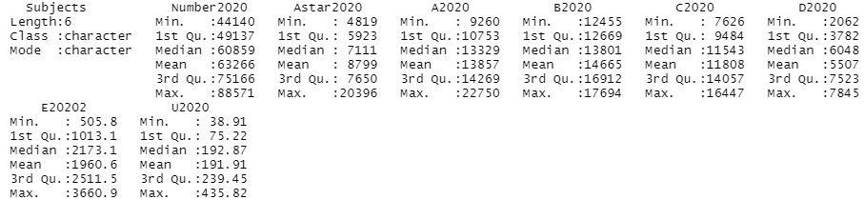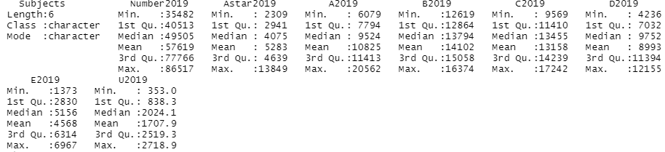
Takes the refined data and plots the selected grade with comparisons from both years respectively
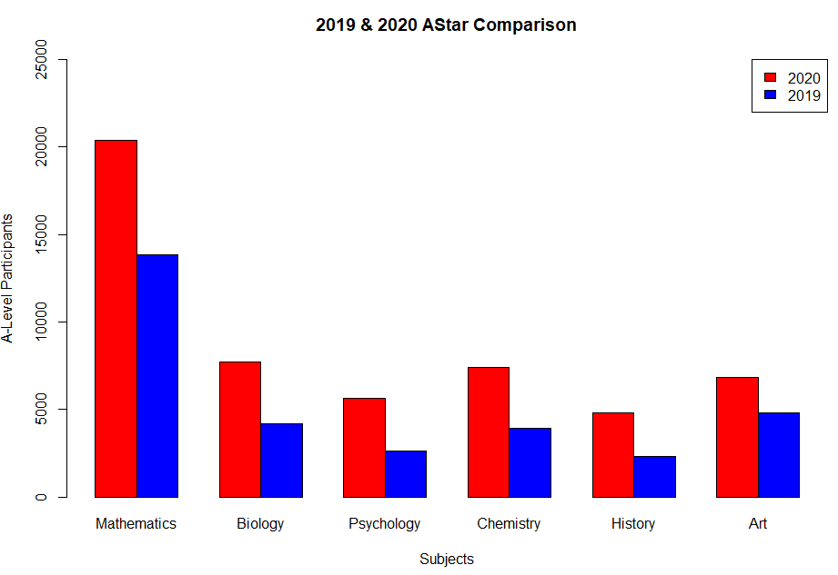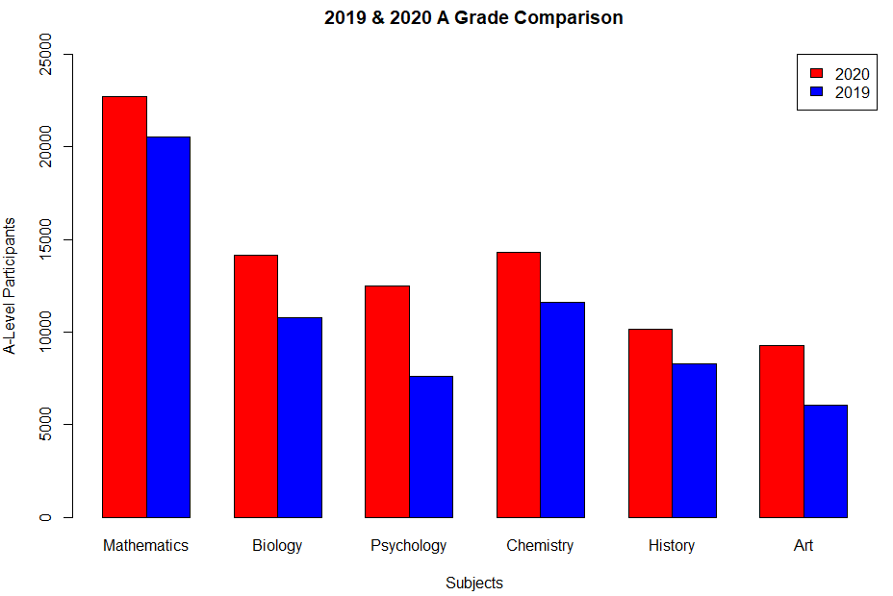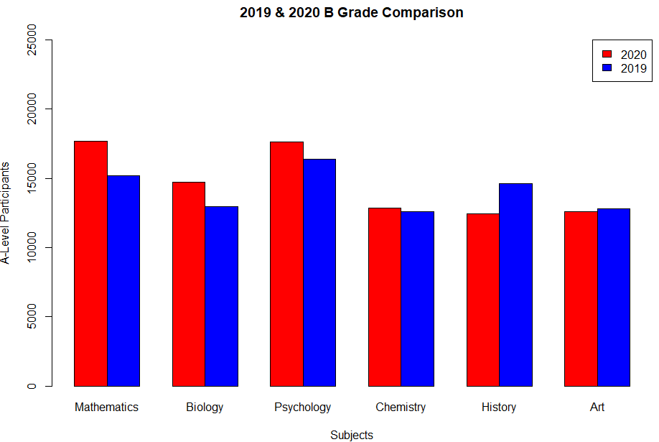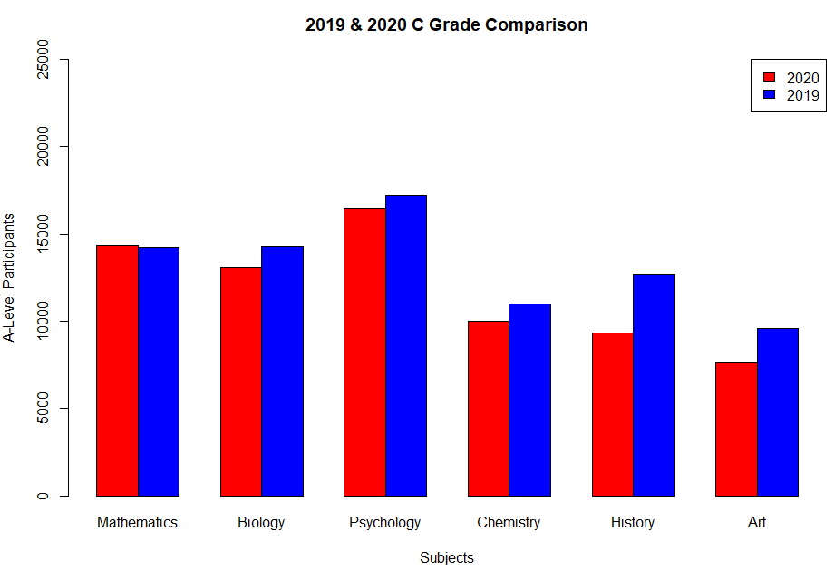
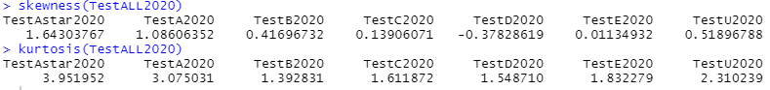
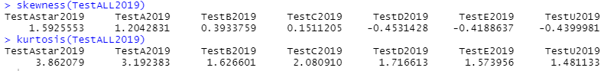
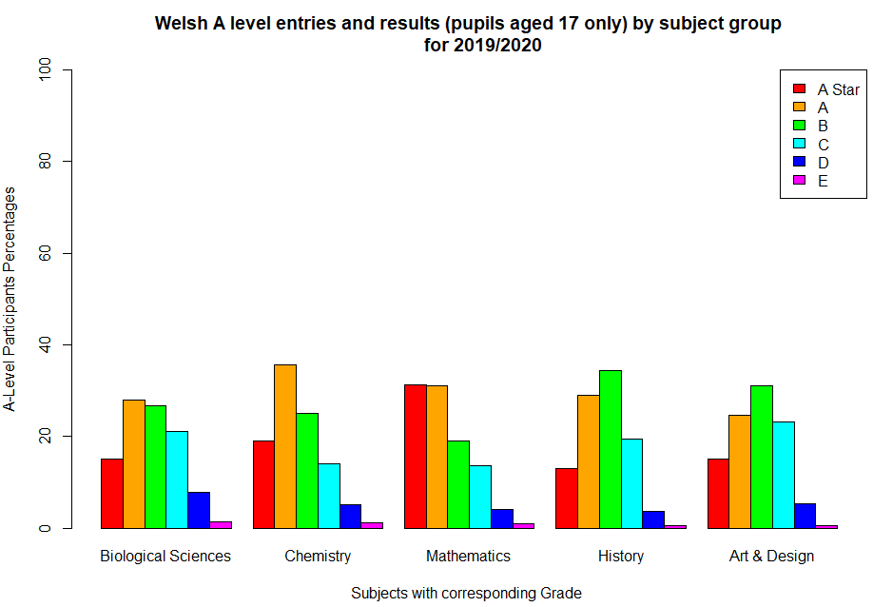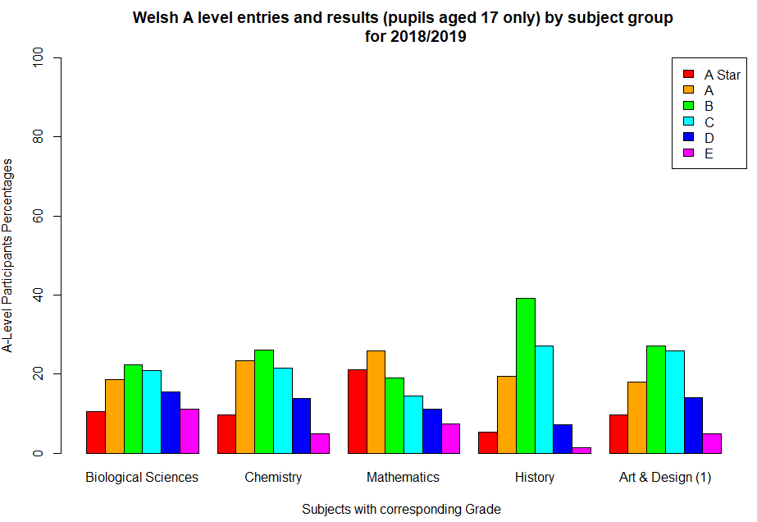
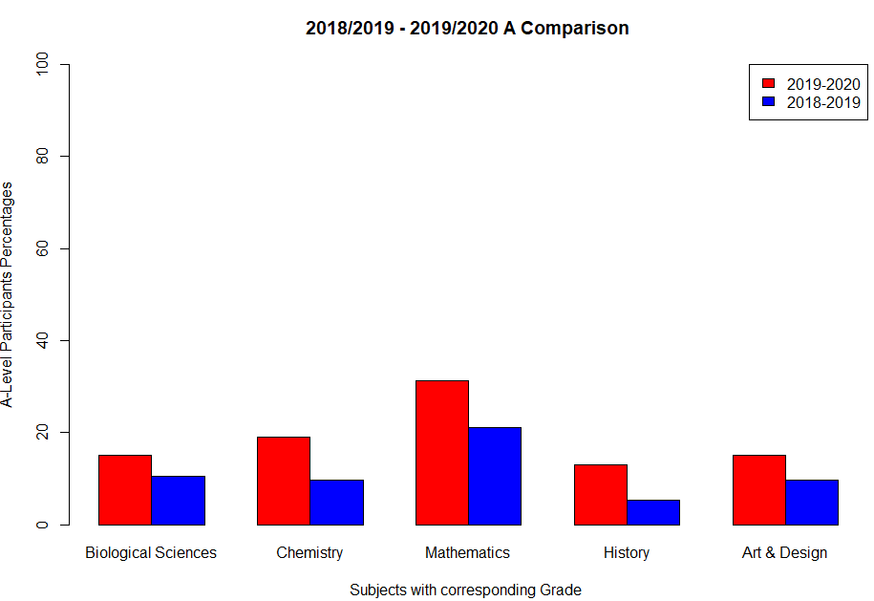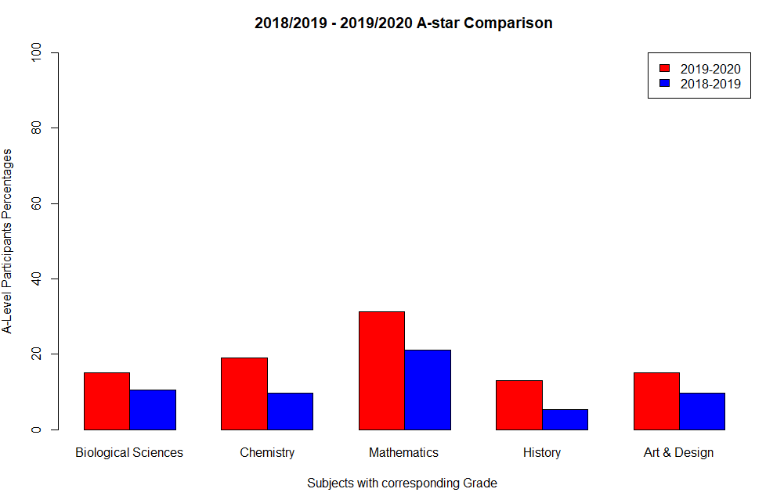

Statistical Methods
For this study it’ll investigate the relative difference in the results between the 2020 and 2019 exams and discusses whether firstly there was a noticeable different in the results and secondly, if so, what could have caused the changes and whether it was significance in its impact. So therefore, from the data and the numerous sources acquired I plan to test the hypothesis that ; There was a drastic change from the A-Level results from 2019-2020 due to the impact the Covid-19 pandemic.
This hypothesis has been thought of due to the impact the Covid-19 pandemic has had in multiple other sectors in our lives and welfare and education is not any exception to this. An example of this was GCSE and A-Level results will be decided by statistical modelling and not just teachers’ predicted grades as the model that Ofqual (who the dataset being analysed by this study is from came out) used will factor previous grades of pupils and former students at same school (CATLING, 2020) thus showing that Covid-19 has already had an Impact.
Therefore, when defining the hypothesis, the use of a decomposition method will be used to decompose the problem into subproblems:
- Relative difference in the results between the 2020 and 2019 exams and discusses whether firstly there was a noticeable different in the results.
- if there were changes in (1), could Covd-19 have caused the changes and whether it was significance in its impact
The assumptions that have been made from the decision for this use of testing was that sample statistics would be used in that the measures calculated from a sample would provide a form of inferential statistics as it’d allow for the Methods of drawing conclusions about a A-Level grades based on information obtained from a sample of those A-Level subjects that contain the largest member participation (Convenience Sampling; Due to multiple subject – decision to use the most participated as due to the larger amounts of participant data, better arguments are able to be formed.). Another assumption that was made was the impact lockdown had on students as they would be worried about predicted grades being lower than those they would have achieved in an exam and felt confused about how their grades would be calculated. This’d lead to a carry-on effect on decisions relating to employment and higher education and has the potential to widen
the inequalities that exist when young people leave compulsory education. So, with these issues, how would one be able to focus on exams as at the time, its future was unknown and young people’s mental health was starting to take main stage. A third assumption was that from viewing the data alone without any influence, it can be seen to show that there was an impact of some kind due to the leap from Astar-U grade results from multiple subjects as highlighted earlier in Psychology but is also noticeable in subjects such as Mathematics and Chemistry. Taking this into consideration and what impacts that could’ve occurred throughout the year, Covid-19 could be seen to take priority. Validity of these assumptions can first be demonstrated through the usage of inferential statistics as due to it allowing analyst to generalize findings to the larger population of students.
- Also be seen to quantifies the performance of the inference results enabling study of most affected area.
- Most importantly, provides a clear framework for how to interpret the results of the inference task as it enables an individual to understand what the results mean and what the limitations are placed in the interpretation by either the data, the inference method, or the modelling done.
Secondly the validity of the impact of lockdown can be expressed throughout numerous sectors and can be seen to affecting people still currently with the educational sector being just an example, so it can be seen to be justified to consider it as an impact especially due to rising mental health impacts that are on the rise each day (Dana Dabbous, 2020). Finally, the last validity is demonstrated similarly to second point but more views the perception that covid-19 has had on the general population and alongside government briefings and numerous articles, as with results being based off a model and not an actual exam many results will be standardised resulting in an increase of higher grades which was supported throughout numerous articles post A-level results day.
Results and Conclusions
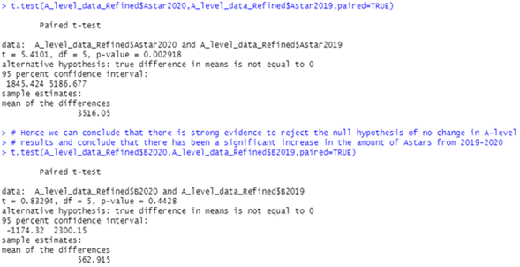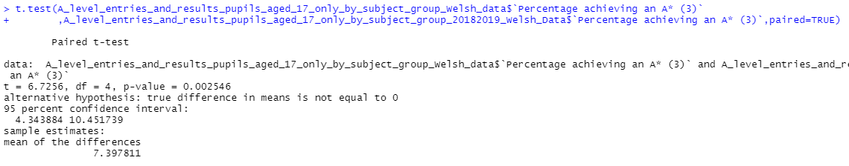

The results of the statistical tests via the hypothesis testing can be demonstrated through the usage of the paired T-test for both the A* & A grade as it involved the testing for the difference between the means; dependant samples – As the elements of the two samples are related by the grades, meaning the samples are to be dependent & When we have dependent samples, we have paired data, and thus the need to perform a paired t-test. Additionally, Paired t-tests are considered more powerful than unpaired t-tests because using the same participants or item eliminates variation between the samples that could be caused by anything other than what’s being tested. The results that were provided were that there is strong evidence to reject the null hypothesis of no change in A-level results and conclude that there has been a significant increase in the amount of Astars/A grade from 2019-2020.
This result can be seen to make sense and confirm multiple sources such as (Express & Star , 2020) as the significant level for both the A Star & A grade test both showed to be below 5% which demonstrates a strong evidence against the null hypothesis as visually from the data alone it suggested that there was a drastic change in some subject having a higher concentration of grades from 2020 compared to 2019. Therefore, the data can be seen to correlate with both the data show visually but also from the graphical summaries provided. When investigating sub-aspects such as the skewness and kurtosis, the skewness for 2020 & 2019 showed majority Positive values indicating data is skewed right – i.e., have right tails which are long relative to the left tail (positively skewed) with a few Negative values indicate data that is skewed left – i.e., have left tails which are long relative to the right tail (negatively skewed) which can make sense as more student are achieving better grades. The kurtosis further supports the results as they were all positive which indicates a “heavy-tailed” distribution – also referred to as Platykurtic.
These results tie in with what I have previously expected from the graphical and numerical summaries as it strongly suggested a drastic change from 2019 to 2020 as the graphical summary of some of the following grades as both the B & C grades showed a decline in the amount achieved whereas the A star and A grade increased by a substantial amount which is expected because less students hitting that mark means either a slight drop off each way or an improvement although with the improvement being a minimum 2000 students with only an 514 students for that learning year, it gives the opinion that there must’ve been another element that played an effect on the result, that being the Covid-19 pandemic and it affects on cancelling exams and causing grades to be based off a statistical model.
However, the data being monitored was only a subset of the initial data that contain similar information but on a reduced participant level, so to improve on the testing more data could be taken into consideration as well as running the test on different subjects. Alongside this the data can be seen to be very broad in that it only considers the grade and no other aspect such as region and predicted grades for those A-level participants as with exams being based on a predictive modelling it considers several factors, including pupils' previous attainment, results of previous students at the same school and the predicted grades teachers submitted in March. So as an improvement, seeing if the predictive grades were also drastically different or just showing slight differences would be an important factor to consider in the data collection. This also applies to regions as with the use of this model it also suggests “huge injustice that pupils will see their results downgraded just because of their postcode.”( Shadow education secretary Kate Green) (Boycott-Owen, 2020) so seeing if the data showed this would have an impact on the hypothesis. As collectively from what is provided and what has been analysed, there was a drastic change from the A-Level results from 2019-2020 due to the impact the Covid-19 pandemic. Additional conclusion to support the hypothesis can also be seen through pair T-test for the wales additional data at with its low P-value it suggested Very strong evidence against H0 which through the graphical summaries, respectively showed a very similar change in grades from 2018-2019 to 2019-2020. As with the same subjects apart from Psychology, there was an increase in each respective grade resulting in a higher percentage of A-stars. So, considering the numerous report and wales being a very close to England and therefore dealing with the impact of Covid-19 in a similar way, it means that its educational sector was also affected thus providing a reasoning for the increase. But as previously outlined for the improvement for collecting the data, the same could be applied to Wales in regional data as well as predictive grades.
R Appendix W. References
In the Zip file: The code will be also attached

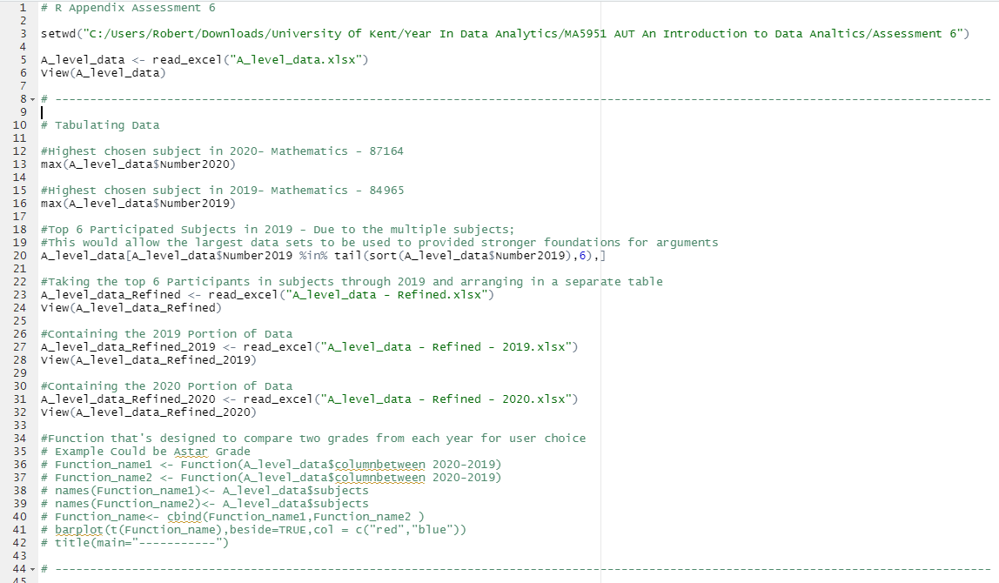
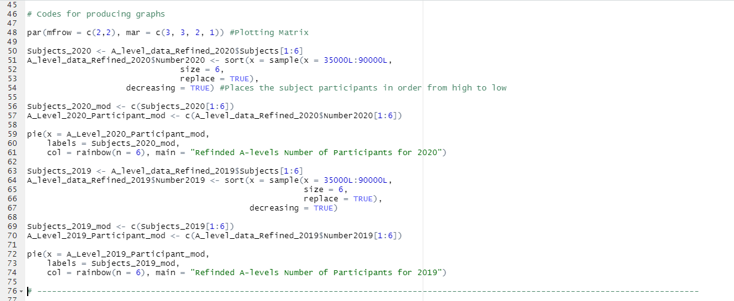
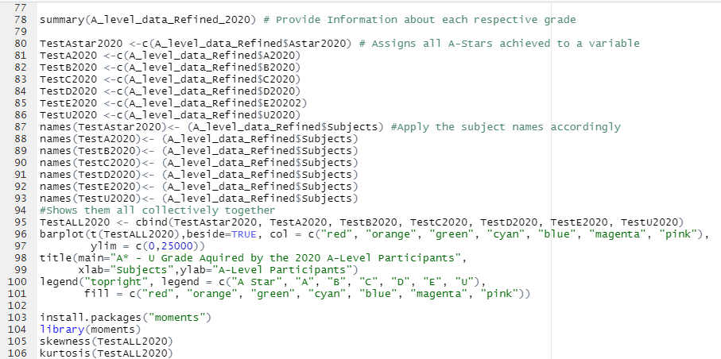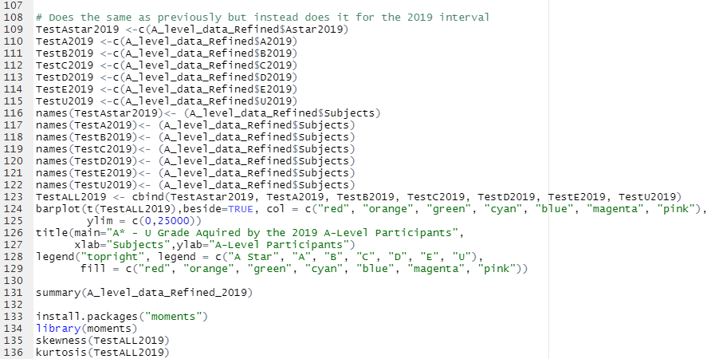
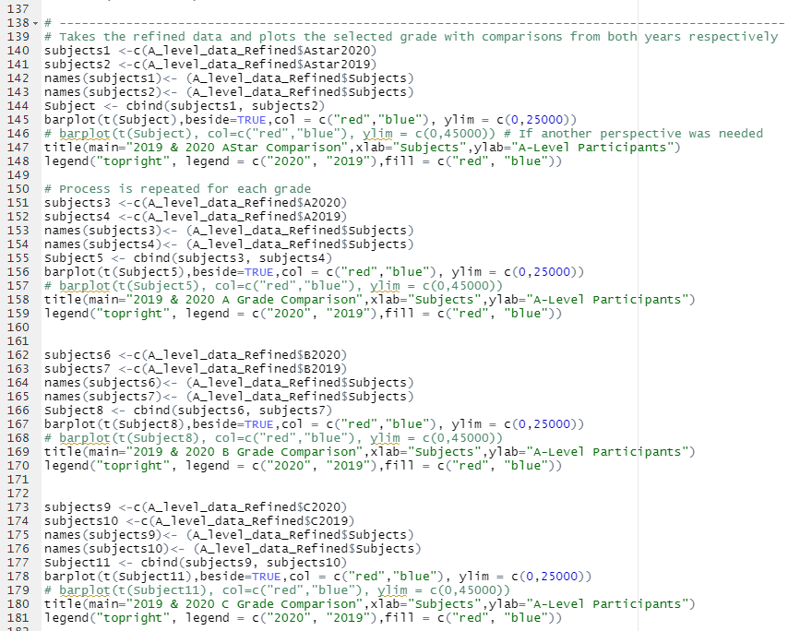
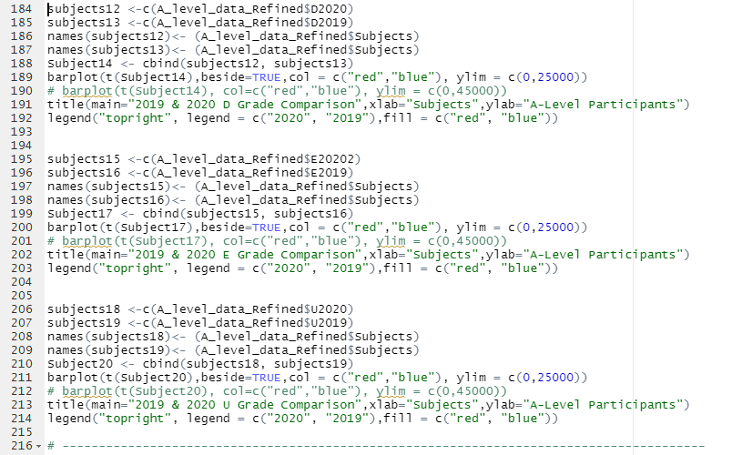
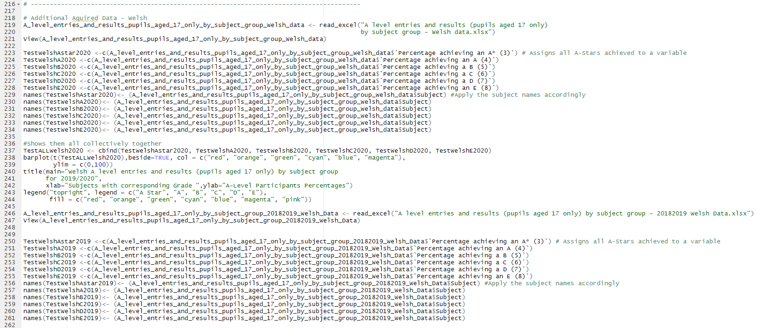
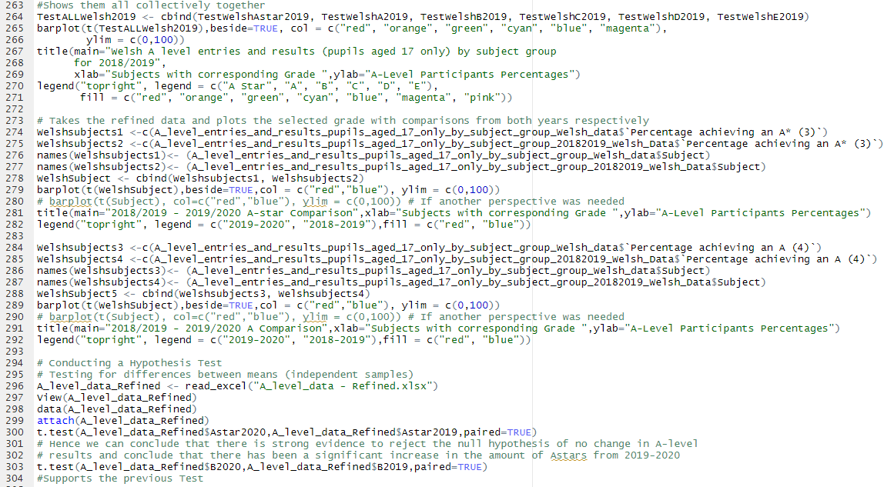

References
Cambridge International. (2020). Cambridge International AS and A Level results statistics. Retrieved from Cambridge assessment international Education: https://www.cambridgeinternational.org/programmes-and-qualifications/cambridge-advanced/cambridge-international-as-and-a-levels/results-statistics/
Express & Star . (2020). Key statistics in this year’s A-level results. Retrieved from Express and Star: https://www.expressandstar.com/news/uk-news/2020/08/13/key-statistics-in-this-years-a-level-results/
Scottish Government. (2020). Results Day. Retrieved from Scottish Government: https://www.gov.scot/news/results-day/
Boycott-Owen, M. (2020, August 13). A-level results: Colleges report more than half of grades being marked down. Retrieved from Telegraph.
Cambridge International. (2020). Cambridge International AS and A Level results statistics. Retrieved from Cambridge assessment international Education: https://www.cambridgeinternational.org/programmes-and-qualifications/cambridge-advanced/cambridge-international-as-and-a-levels/results-statistics/
CATLING, L. (2020, August 4). GCSE and A-Level results will be decided by statistical modelling – not just teachers’ predicted grades. Retrieved from DailyMail: https://www.dailymail.co.uk/news/article-8561391/GCSE-Level-results-decided-statistical-modelling-NOT-teachers-predicted-grades.html
Dana Dabbous, A. d. (2020). The Impact of Covid-19 on Education:evidence on the early impacts of lockdown. Edge Foundation (2020).
Express & Star . (2020). Key statistics in this year’s A-level results. Retrieved from Express and Star: https://www.expressandstar.com/news/uk-news/2020/08/13/key-statistics-in-this-years-a-level-results/
Scottish Government. (2020). Results Day. Retrieved from Scottish Government: https://www.gov.scot/news/results-day/

